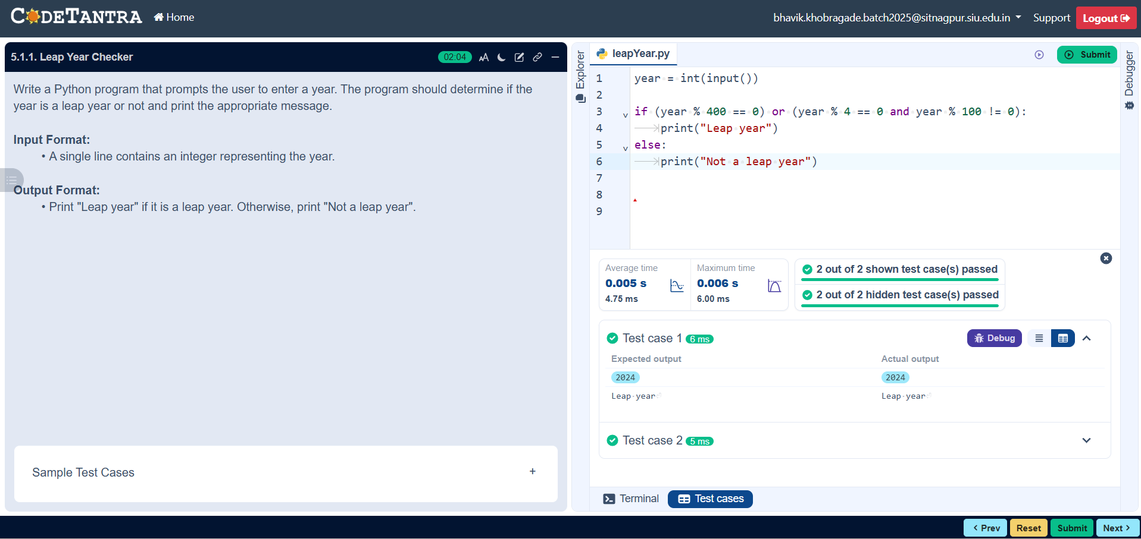

5.1.1

Leap Year Checker Program

Algorithm:

Step 1: Start the program.

Step 2: Input the year from the user.

Step 3: Check if (year % 400 == 0) OR (year % 4 == 0 AND year % 100 != 0).

Step 4: If the condition is true, print "Leap year".

Step 5: Otherwise, print "Not a leap year".

Step 6: End the program.

Python Code:

year = int(input())

if (year % 400 == 0) or (year % 4 == 0 and year % 100 != 0):

print("Leap year")

else:

print("Not a leap year")

Execution:

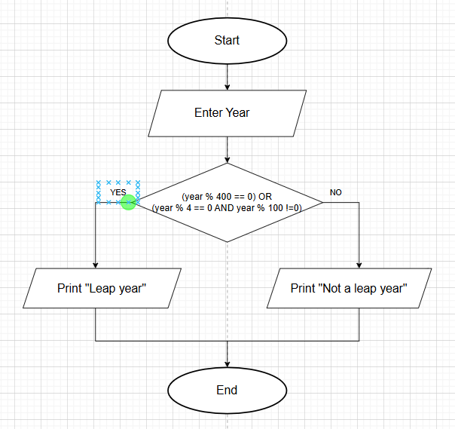
Flowchart:

